作业说明：

1、请大家观看完成第七章5节内容。

2、请大家仔细观看第七章 第8节《Jsp连接数据库总结》中我录制的视频《学生管理系统导入》、《学生管理系统登录》，然后完成作业。提交作业时请先将代码复制，然后将执行效果截图；家里没有电脑的同学，请观看视频后进行笔记记录，通过手机图片的形式进行作业提交。

3、学有余力的同学，请将我所讲授的内容都进行敲写一遍的操作。尽快熟悉。

第十三周作业：

**【练习】完成学生管理系统的登录。**

截图：

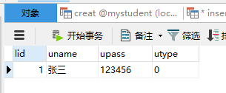

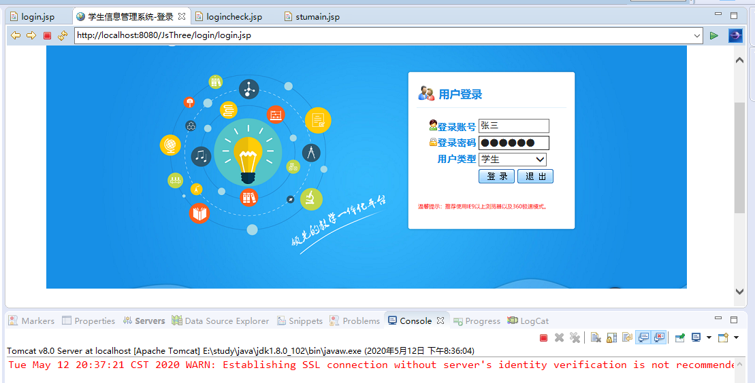

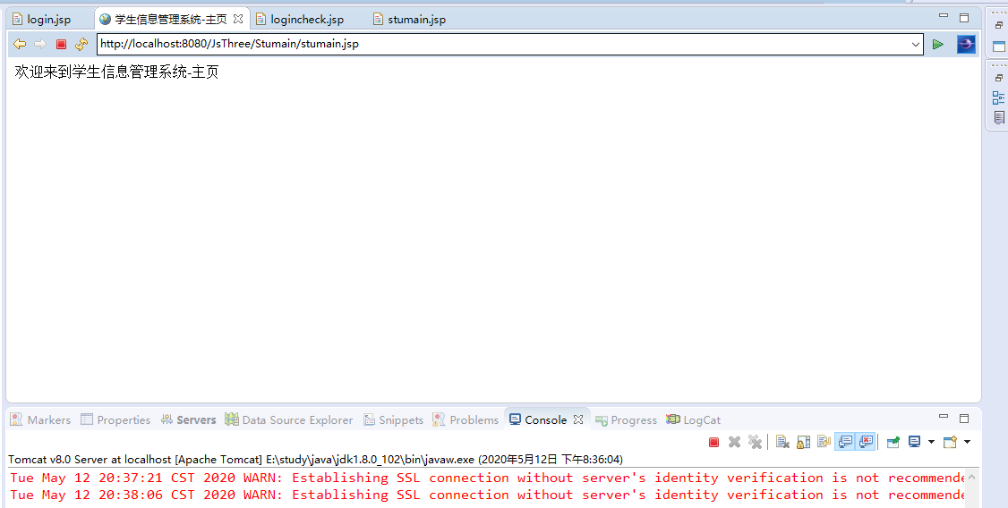

**代码**

login.jsp

<%@ page language=*"java"* contentType=*"text/html; charset=UTF-8"*

pageEncoding=*"UTF-8"*%>

<!DOCTYPE html PUBLIC "-//W3C//DTD HTML 4.01 Transitional//EN" "http://www.w3.org/TR/html4/loose.dtd">

<html>

<head>

<meta http-equiv=*"Content-Type"* content=*"text/html; charset=UTF-8"*>

<title>学生信息管理系统-登录</title>

</head>

<body>

<form action=*"logincheck.jsp"* name=*"loginForm"* style="background-image: *url(../images/login-logo.png)*;width:*952px*;height:*680px*;background-repeat:*no-repeat*;margin-top:*50px*; margin-left:*auto*;margin-right:*auto*">

<table style="padding-left:*560px*;padding-top:*170px*;">

<tr>

<td align=*"right"* style="color:*#0086E3*;font-weight:*bold*;font-family:*黑体*;font-size:*14px*;">

<img src=*"../images/iconName.gif"*>登录账号

</td>

<td>

<input type=*"text"* align=*"left"* name=*"userNo"* style="width:*100px*;font-family: *黑体*;" maxlength=*"8"* title=*"请输入用户名"*/>

</td>

</tr>

<tr>

<td align=*"right"* style="color:*#0086E3*;font-weight:*bold*;font-family:*黑体*;font-size:*14px*;">

<img src=*"../images/iconPassword.gif"*>登录密码

</td>

<td>

<input type=*"password"* align=*"left"* name=*"password"* style="width:*100px*;font-family: *黑体*;" maxlength=*"10"* title=*"请输入密码"*/>

</td>

</tr>

<tr>

<td align=*"right"* style="color:*#0086E3*;font-weight:*bold*;font-family:*黑体*;font-size:*14px*;">

用户类型

</td>

<td align=*"left"*>

<select name=*"userType"* style="width:*100px*;">

<option value=*""*>请选择...</option>

<option value=*"0"*>学生</option>

<option value=*"1"*>教师</option>

<option value=*"2"*>管理员</option>

</select>

</td>

</tr>

<tr>

<td align=*"right"*>

&nbsp;

</td>

<td align=*"left"*>

<input type=*"submit"* style="background: *url(../images/btnLogin.gif)*;border-style: *none*;width:*53px*;height:*21px*;background-repeat: *no-repeat*;" value=*""* onclick="return check();"/>

<input type=*"submit"* style="background: *url(../images/btnLogout.gif)*;border-style: *none*;width:*53px*;height:*21px*;background-repeat: *no-repeat*;" value=*""*"/>

</td>

</tr>

</table>

</form>

<script>

**function** check(){

**var** form = document.loginForm;

**if**(form.userNo.value == ""){

alert("请输入登录账号!");

form.userNo.focus();

**return** **false**;

}

**if**(form.password.value == ""){

alert("请输入登录密码!");

form.password.focus();

**return** **false**;

}

**if**(form.userType.value == ""){

alert("请选择类型!");

form.userType.focus();

**return** **false**;

}

**return** **true**;

}

</script>

</body>

</html>

logincheck.jsp

<%@page import=*"java.sql.SQLException"*%>

<%@page import=*"java.sql.ResultSet"*%>

<%@page import=*"java.sql.Statement"*%>

<%@page import=*"java.sql.DriverManager"*%>

<%@page import=*"java.sql.Connection"*%>

<%@ page language=*"java"* contentType=*"text/html; charset=UTF-8"*

pageEncoding=*"UTF-8"*%>

<!DOCTYPE html PUBLIC "-//W3C//DTD HTML 4.01 Transitional//EN" "http://www.w3.org/TR/html4/loose.dtd">

<html>

<head>

<meta http-equiv=*"Content-Type"* content=*"text/html; charset=UTF-8"*>

<title>Insert title here</title>

</head>

<body>

<%

request.setCharacterEncoding("utf-8");

String name = request.getParameter("userNo");

String password = request.getParameter("password");

String type = request.getParameter("userType");

session.setAttribute("name", name);

session.setAttribute("type", type);

// 1.加载jdbc驱动程序

**try**{

Class.forName("com.mysql.jdbc.Driver");

}**catch**(ClassNotFoundException e){

System.out.println("找不到驱动程序类，加载驱动类失败");

}

// 2.提供jdbc链接URL

**try**{

String url = "jdbc:mysql://localhost:3306/mystudent?serverTimezone=GMT&useUnicode=true&characterEncoding=utf-8"; // 协议 数据库类型 地址端口 数据库

String user = "root";

String pwd = "tiger";

Connection con = DriverManager.getConnection(url, user, pwd);

Statement stmt = con.createStatement();

String sql = "select * from login where Uname = '"+name+"' and Upass = '"+password+"' and Utype = '"+type+"'";

ResultSet rs = stmt.executeQuery(sql);

**if**(rs.next()){

response.sendRedirect("../Stumain/stumain.jsp");

}**else**{

response.sendRedirect("login.jsp");

}

rs.close();

stmt.close();

con.close();

}**catch**(SQLException e){

System.out.println("数据库操作失败");

e.printStackTrace();

}

%>

</body>

</html>